USB 3.0 PCI Express Adapter User Guide

USB 3.0 Features
Compliant with USB 3.0 specification Revision 1.0
- Supports the following speed data rate as follows :Low/Full/High & Super-speed.( 1.5/12/480/5G Mbps)
- Supports 4 downstream ports for all speed
- Compliant with Intel’s extensible Host Controller Interface(xHCI) specification revision 0.95
- Compliant with PCI Express Base Specification 2.0
- Supports PCI Express Card Electromechanical Specification 2.0
- Supports PCI Bus Power Management Interface Specification revision 1.2
- Single-lane ( x1) PCI Express throughput rates up to 5 Gbps
- Each USB port supplies maximum +5V / 900mA power output to USB device.

Package Contents
This PCI Express USB 3.0 Card package includes the following:
• USB 3.0 PCI Express Adapter Card • CD Driver
• User Manual

OS Supported
- Windows® XP/Vista and Win 7 (32/64-bit)operation system

Configuration
．The USB 3.0 Express Adapter Card
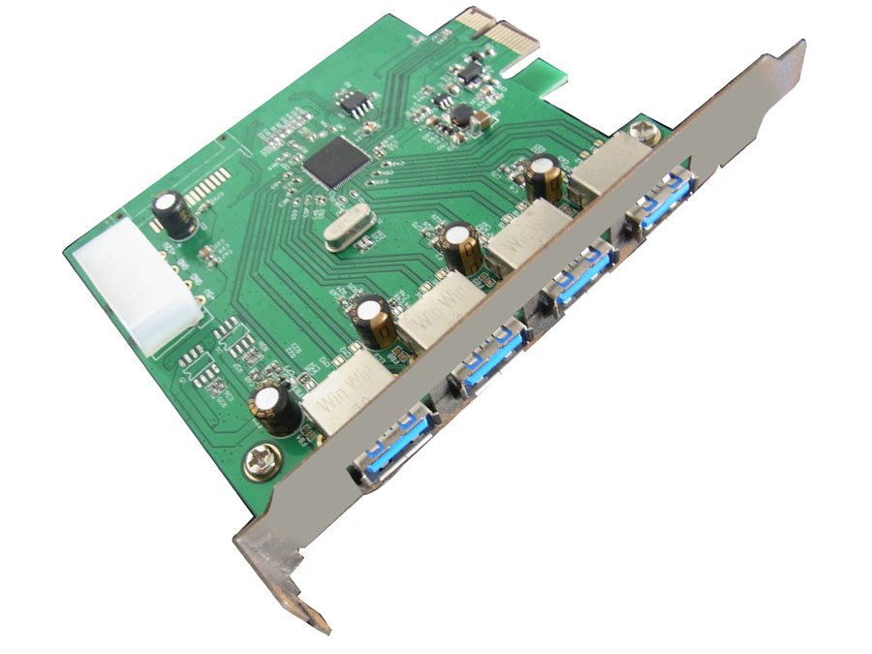1
This section provides information on how to install the Super PCI-E drivers for the following operating systems:

Driver Installation:
Star Windows OS,USB3.0 Express card will be detected by system. Please install driver as below steps:

- Please insert the attached CD into your CD-ROM and click the Installshiedl Wizard for driver installation
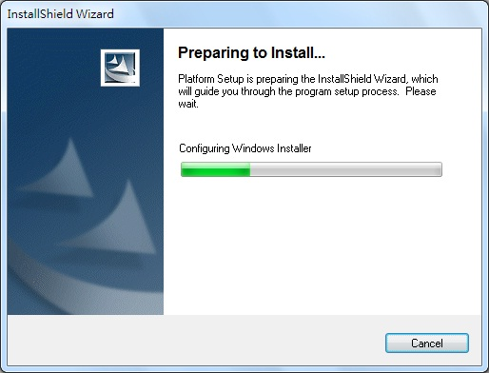

- Click ”Next” to continue.
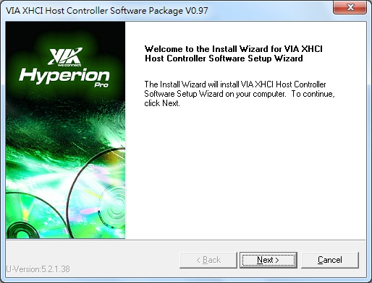

2

- Check “License Agreement” and click “I Agree” to enter to next step.
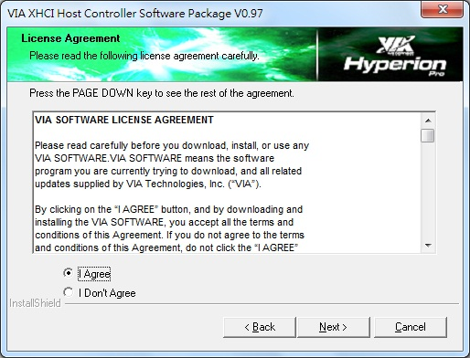

5. Choose “VIA XHCI Host Controller Driver” and click “NEXT”
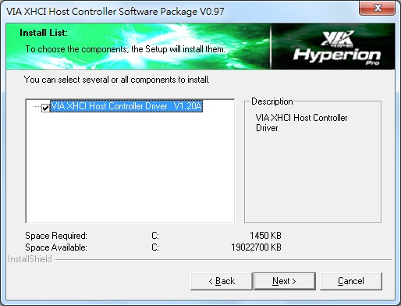

3

- Click “Next” to start the driver installation.

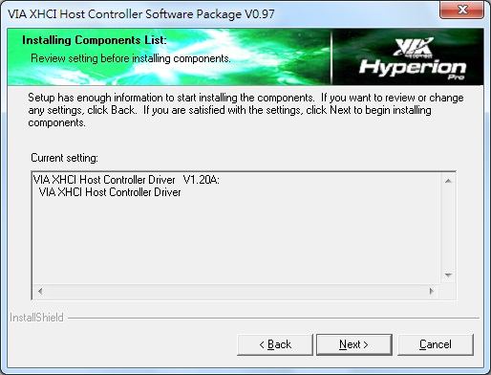

6. To check the driver installation status.

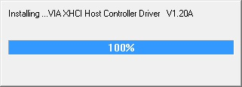

4.
7. The dialogue will show you if the components of the driver is installed successfully.
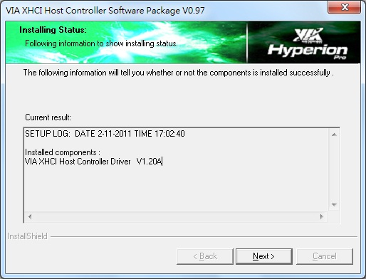

8. After installation, pls click “Finsih”

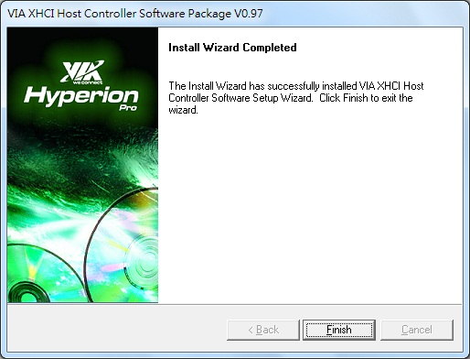

5.
To verify successful installation in Windows®:

From the main desktop, click on “My Computer”, then double-click on “Control Panel, System”, and“ Device Manager” , and “Universal Serial Bus controllers” to “NEC Electronics USB 3.0 Host Controller”

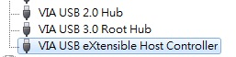

6

